How to take and track attendance with Orange SUccess
Every instructor or TA with an active section will automatically have access to Orange SUccess through MySlice and Blackboard accounts. Find and click the link in the “faculty services” pagelet of MySlice or “tools” panel of Blackboard. The Record Attendance tab will appear on your Home page.

The general steps are:
- Click the Record Attendance button.
- Select a section.
- Select a meeting time.
- Record or edit attendance.
- Review attendance data as needed.
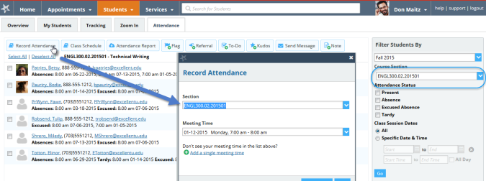See below for additional details on each of these steps.

Select the Record Attendance Button
Select the Record Attendance button in either of the following locations:
- The Orange SUccess Home page
- The Attendance sub-tab within the Students tab

Select a Section
Select a section from the drop down list presented. If you are starting from the Attendance tab and a section has been selected from within the filters on the right of the page, that section will be the default in the drop down list. From the Meeting Time menu, select a meeting time for which to record attendance, or click the Add a single meeting time link to record attendance for a one-time session.
Visit http://orangesuccess.syr.edu or send an email to orangesuccess@syr.edu if you have any questions.

